Step 1:

Open letswave, select the datasets for statistical analysis.

Here we select the a dataset in the example_data folder for one-sample.

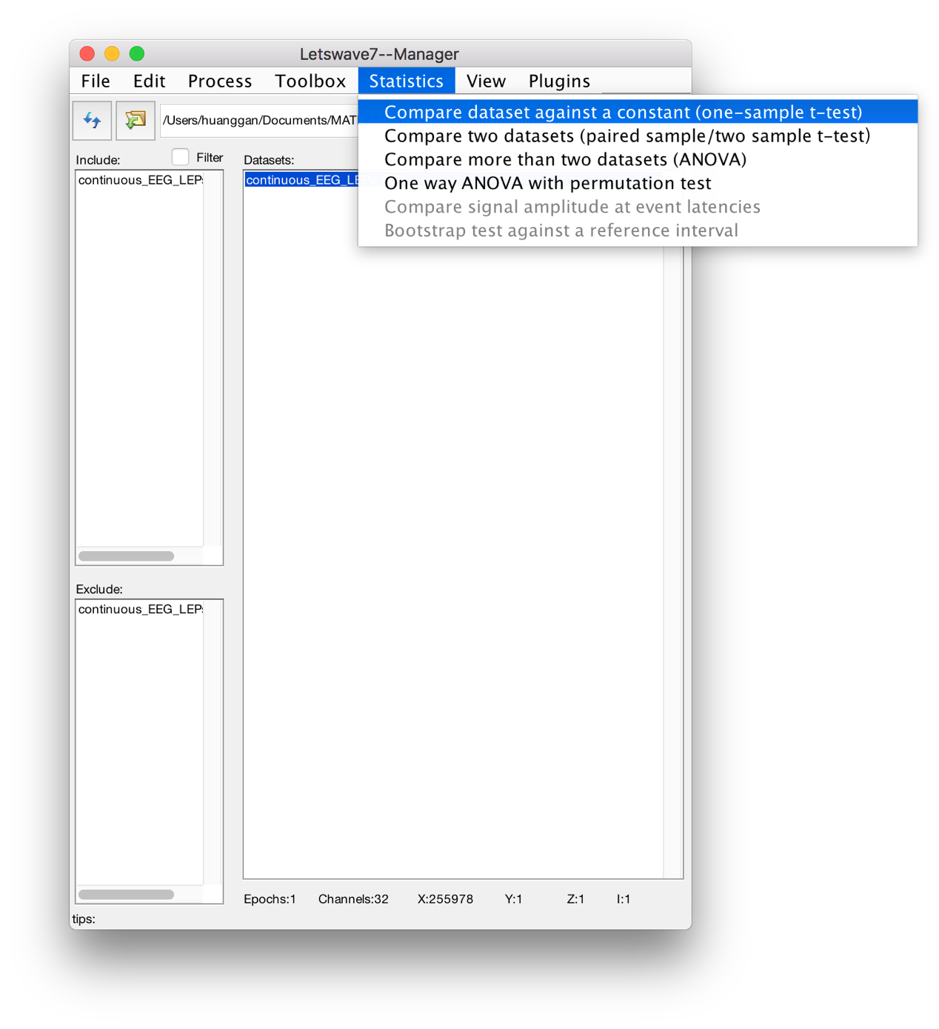

# Step 2:

Set the parameters for test. Enable the check box if you want to do cluster-based permutation test.

Enable the checkbox in the multiple sensory analysis panel for the permutation test in the temperal-spatial domain.

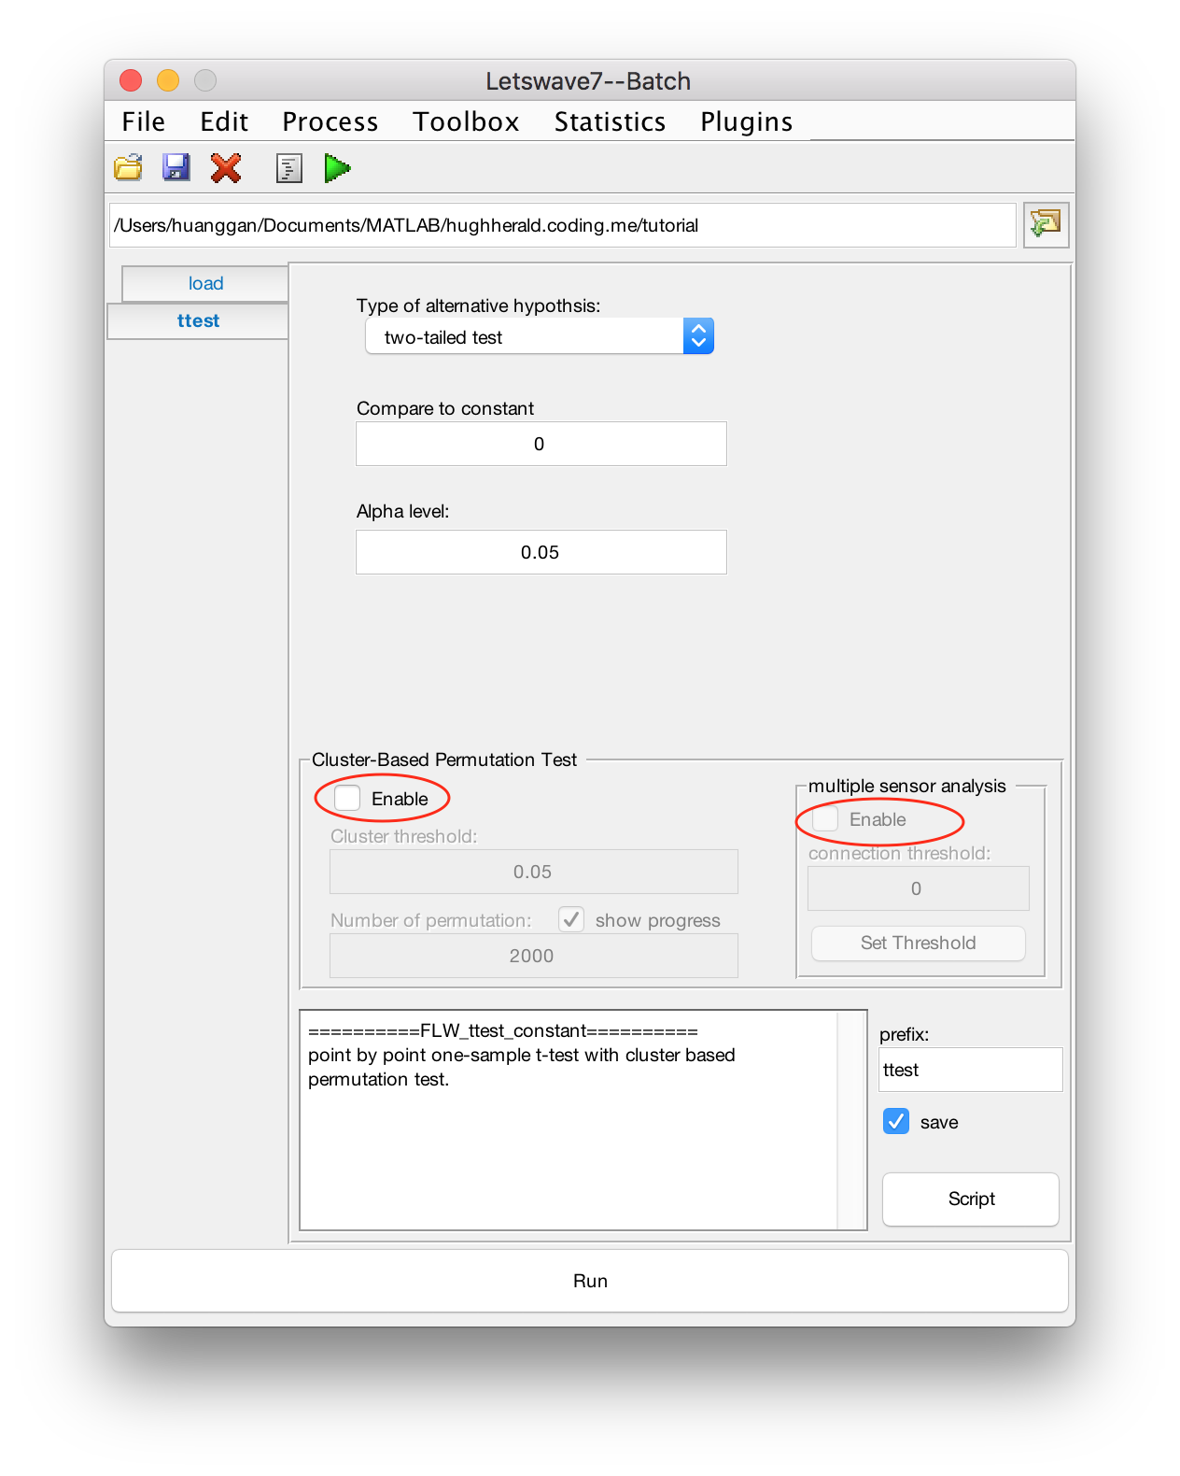

# Step 3:

Click the "Set Threshold" button, use the slider to set the threshold for the topological connection. Then press "OK" to return.

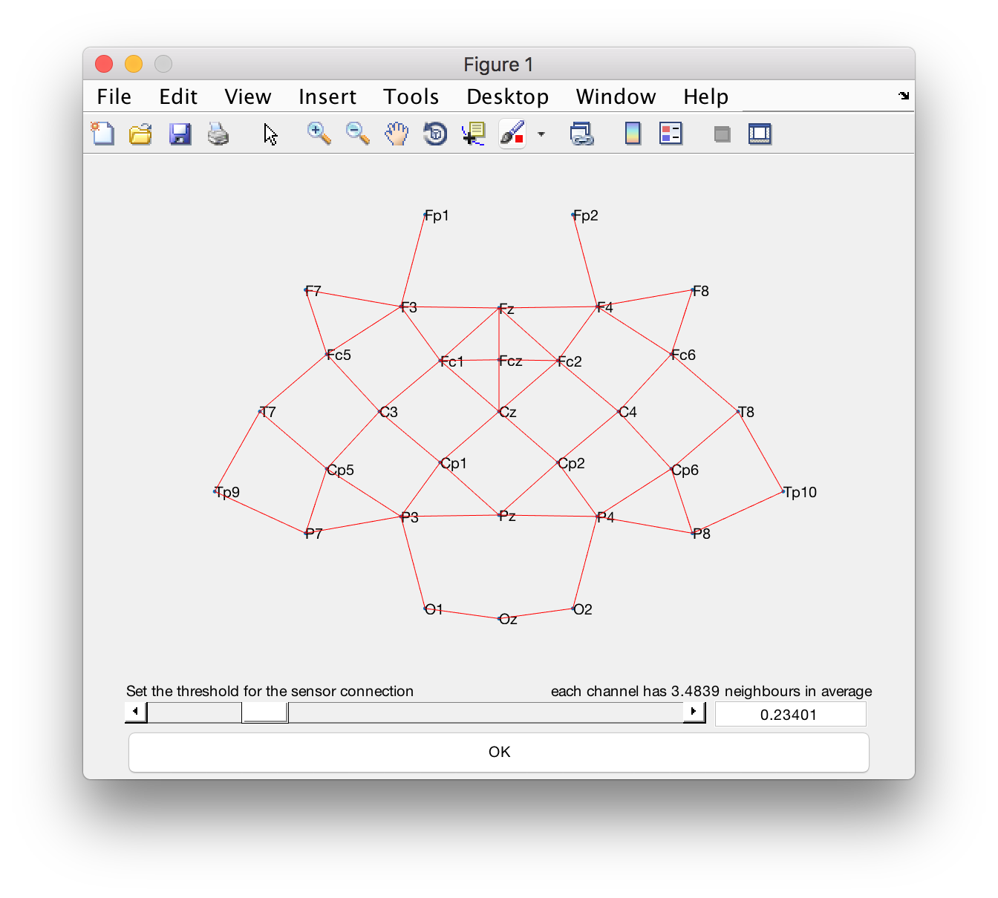

# Step 4:

Press button "Run" to run the permutation test, or you can click the button "script" in the toolbar to see the script. Directly runing the script in the command window or in the m-file equals to Press button "Run" in the GUI panel.

